**Generalized Kudryashov method for solving some (3+1)-dimensional nonlinear evolution equations**

Md. Shafiqul Islam 1*, Kamruzzaman Khan 1, Ahmed.H.Arnous2

1* Department of Mathematics, Pabna University of Science and Technology, Pabna-6600, Bangladesh.

1 Department of Mathematics, Pabna University of Science and Technology, Pabna-6600, Bangladesh.

**Corresponding Author's Email:** shafiquemath31@gmail.com

2 Department of Engineering Mathematics and Physics, Higher Institute of Engineering, El Shorouk, Egypt.

**Abstract**

In this work, we have applied the generalized Kudryashov methods to obtain the exact travelling wave solutions for the (3+1)-dimensional Jimbo-Miwa (JM) equation, the (3+1)-dimensional Kadomtsev-Petviashvili (KP) equation and the (3+1)-dimensional Zakharov-Kuznetsov (ZK). The attained solutions show distinct physical configurations. The constraints that will guarantee the existence of specific solutions will be investigated. These solutions may be useful and desirable for enlightening specific nonlinear physical phenomena in genuinely nonlinear dynamical systems.

**Key words:** Generalized Kudryashov method; JM equation; KP equation; ZK equation; exact solution; NLEEs.

**Mathematics Subject Classification:** 35K99, 35P05, 35P99.

**PACS numbers:** 02.30.Jr, 02.70.Wz, 05.45.Yv, 94.05.Fg.

**Introduction**

In the last few decades’ nonlinear evolution equations (NLEEs) has become special classes of the category of partial differential equations (PDEs). It is renowned that finding exact solutions for NLEEs, by using different abundant methods plays an energetic role in mathematical physics and become one of the furthermost exciting and awfully active areas of research investigation for mathematicians and physicist. Many important phenomena and dynamic processes in physics, mechanics, chemistry and biology can be represented by nonlinear partial differential equations. Nonlinear wave phenomena of dispersion, dissipation, diffusion, reaction and convection are energetic prominence in NLEEs. It is essential to determine exact traveling solutions for these nonlinear equations to allow us to get an insight through qualitative and quantifiable properties of these equations. These days the research area of NLEEs has made a significant progress. There has been a rising concentration in finding exact analytical solutions to nonlinear wave equations by means of appropriate technique. Particularly, the existence of soliton solutions for NLEEs is of abundant importance because of their prospective applications in many physics areas such as chaos, mathematical biology, diffusion process, plasma physics, optical fibers, neural physics, solid state physics etc. In recent years, quite a few methods for obtaining explicit traveling and solitary wave solutions of NLEEs have been proposed and developed. A variety of powerful methods such as, homogeneous balance method [1, 2], auxiliary equation method[3, 4], the Exp-function method [5, 6], Darboux transformation method [7, 8], the tanh-function method [9], the modified extended tanh-function method [10], Jacobi elliptic function method [11, 12], the first integral method [13, 14], the modified simple equation method [15-17], the -expansion method [18-25], the homotopy perturbation method [26-30], the exp-expansion method [31], the variational iteration method [32] and the *F*-expansion method [33-35] and so on.

The Jimbo-Miwa equation was first announced by M. Jimbo and T. Miwa [36] and it is well-known that this model is not Painlevé integrable. For many years many expert have researched it and certain explicit solutions have been obtained [37-39]. Exact three-wave solutions as well as periodic cross-kink wave solutions, doubly periodic solitary wave solutions and breather type of two-solitary wave solutions for the Jimbo-Miwa equation have been attained using the generalized three-wave method in [40]. The KP equation is used to model shallow-water waves with weakly non-linear restoring forces. It is a natural generalization of the KdV equation and it gives multiple soliton solutions. The ZK equation governs the behavior of weakly nonlinear ion-acoustic waves in plasma comprising cold ions and hot isothermal electrons in the presence of a uniform magnetic field [41].

In this work we would like to use the generalized Kudryashov methods to seek the exact travelling wave solutions for the (3+1)-dimensional Jimbo-Miwa (JM) equation, the (3+1)-dimensional Kadomtsev-Petviashvili equation and the (3+1)-dimensional Zakharov-Kuznetsov (ZK) equation. The main advantage of this method over the existing other methods is that it provides more new exact traveling wave solutions.

The layout of this paper is systematized as follows. In Section 2, we give the description of

the generalized Kudryashov method. In section 3, we apply this method to the Jimbo-Miwa equations, the Kadomtsev-Petviashvili equation and the Zakharov-Kuznetsov equation. In section 4, we discuss the graphical representation of some obtained solutions and the sections 5, we briefly make a summary to the results that have been obtained.

**2. Algorithm of the generalized Kudryashov method**

In this section, we describe the generalized Kudryashov method for finding the exact traveling wave solutions of NLEEs.

Suppose that we have NLEEs of the form

,, , (1)

where is an unknown function,  is a polynomial in and its various partial derivatives, in which the highest order derivatives and nonlinear terms are involved.

The foremost steps of generalized Kudryashov method are as follows [42]

**Step 1:** The traveling wave transformation  transform Eq. (1) into an ordinary differential equation of the form

, (2)

Step 2: Suppose that the solution of Eq. (3) has the following form

, (3)

where and are constants to be determined later such  and , and  satisfies the ordinary differential equation

. (4)

The solutions of Eq. (4) are as follows:

. (5)

**Step 3:** Determine the positive integer numbers *N* and *M* in Eq. (3) by using the homogeneous balance method between the highest order derivatives and the nonlinear terms in Eq. (2).

**Step 4:** Substituting Eqs. (3) and (4) into Eq. (2), we obtain a polynomial in , (). In this polynomial equating all terms of same power and equating them to zero, we obtain a system of algebraic equations which can be solved by the Maple or Mathematica to get the unknown parameters and , . Consequently, we obtain the exact solutions of Eq. (1).

**3. Application**

**3.1 The (3+1)-dimensional Jimbo-Miwa (JM) equation**

In this subsection we will find the exact traveling wave solutions of the Jimbo-Miwa (JM) equation through the generalized Kudryashov method.

Let us consider the (3+1)-dimensional JM equation [38] of the form

 (6)

Using the traveling wave transformation of the form

, (7)

Eq. (6) is converted into the following ordinary differential equation

 , (8)

Eq. (8) is integrable, therefore, integrating once Eq. (8) with respect to  and neglecting the constant of integration, we obtain

 , (9)

Considering the homogeneous balance between the highest order nonlinear derivative  and nonlinear term of the highest order in Eq. (9), we attain 

If we choose then 

Hence for and Eq. (3) reduces to

 (10)

where and are constants to be determined later.

Now substituting Eq. (10) into Eq. (9), we get a polynomial in, equating the coefficient of same power of, we attain the following system of algebraic equations:

















Solving the above system of equations for and, we attain the following values:

Set 1: 

Set 2: 

Set 1 corresponds the following solutions for Jimbo-Miwa equation



where 

Set 2 corresponds the following solutions for Jimbo-Miwa equation



where 

**Remark:** All of these solutions have been verified with Maple by substituting them into the original solutions.

**3.2 The (3+1)-dimensional Kadomtsev-Petviashvili (KP) equation**

In this subsection we will construct the generalized Kudryashov method to find the exact traveling wave solutions of the (3+1)-dimensional Kadomtsev-Petviashvili (KP) equation which is an important nonlinear equation in mathematical physics. Let us consider the (3+1)-dimensional KP equation [43]

 (11)

The KP equations describe the dynamics of solitons and nonlinear waves in plasma physics and fluid dynamics [44].

We investigate the solutions of the KP equation by the method described in section 2.The wave transformation (7) reduces Eq. (11) into the following ordinary differential equations

 (12)

Eq. (12) is integrable, therefore, integrating twice and neglecting the constant of integration, we obtain

 (13)

Considering the homogeneous balance between the highest order nonlinear derivative  and nonlinear term of the highest order in Eq. (13), we attain 

If we choose then 

Hence for and Eq. (3) reduces to

 (14)

where and are constants to be determined later. Now substituting Eq. (14) into Eq. (13), we get a polynomial in, equating the coefficient of same power of , we attain the following system of algebraic equations:

















Solving the above system of equations for and, we attain the following values:

Set 1: 

Set 2: 

Set 1 corresponds the following solutions for KP equation



where 

Set 2 corresponds the following solutions for KP equation



where 

**Remark:** All of these solutions have been verified with Maple by substituting them into the original solutions.

**3. 3 The (3+1)-dimensional Zakharov-Kuznetsov (ZK) equation**

In this subsection, we will apply the generalized Kudryashov method to construct new exact traveling wave solutions to the Zakharov-Kuznetsov (ZK) equation.

Let us consider the (3+1)-dimensional ZK equation [17] is of the form

 (15)

Where  is a positive constant. The ZK equation is a generalization of the KdV equation. The ZK equation governs the behavior of weakly nonlinear ion-acoustic waves in plasma comprising cold ions and hot isothermal electrons in the presence of a uniform magnetic field. The ZK equation, which is a more isotropic, was first derived for describing weakly nonlinear ion-acoustic waves in strongly magnetized lossless plasma in two dimensions. It was found that the solitary wave solutions of the ZK equation are inelastic.

We investigate the solutions of the ZK equation by the method described in section 2.The wave transformation (7) reduces Eq. (15) into the following ordinary differential equations

 (16)

Integrating once and neglecting the constant of integration, we obtain

 (17)

Taking the homogeneous balance between the highest order term  and the derivative term from Eq. (17), yields 

If we choose then 

Hence for and Eq. (3) reduces to

 (18)

where and are constants to be determined later. Now substituting Eq. (18) into Eq. (17), we get a polynomial in, equating the coefficient of same power of , we attain the following system of algebraic equations:











Solving the above system of equations for and, we attain the following values:

Set 1: 

Set 2: 

Set 3: 

Set 4: 

Set 5: 

Set 6: 

Set 1 corresponds the following solutions for ZK equation



where 

Set 2 corresponds the following solutions for ZK equation



where 

Set 3 corresponds the following solutions for ZK equation



where 

Set 4 corresponds the following solutions for ZK equation



where 

Set 5 corresponds the following solutions for ZK equation



where 

Set 6 corresponds the following solutions for ZK equation



where .

**Remark:** All of these solutions have been verified with Maple by substituting them into the original solutions.

**4. Graphical representation of some obtained solutions**

Graphical representation is a significant instrument for communication and it exemplifies evidently the solutions of the problems. We plot solutions and for (3+1)-dimensional Jimbo-Miwa (JM) equation in Figures 1-2, solutions and for (3+1)-dimensional Kadomtsev-Petviashvili (KP) equation in Figures 3-4 and solutions and for (3+1)-dimensional Zakharov-Kuznetsov (ZK) equation in Figures 5-6 along with . The graphs eagerly have shown the solitary wave form of the solutions.

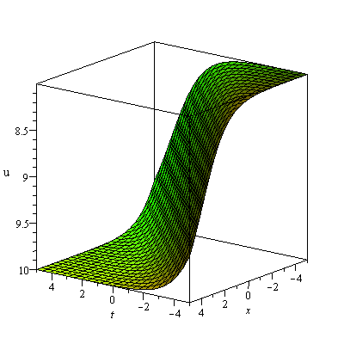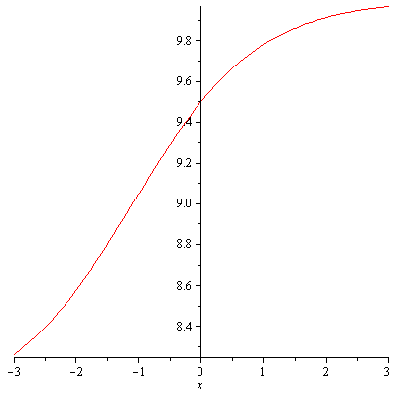

Fig. 1: Kink shaped soliton of JM equation for within the interval. (Only shows the shape of), the left figure shows the 3D plot and the right figure shows the 2D plot for.

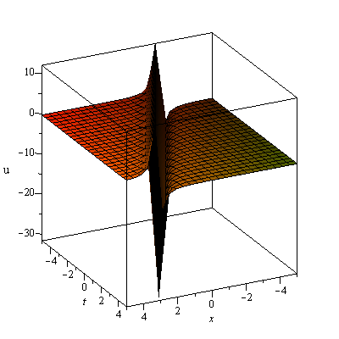 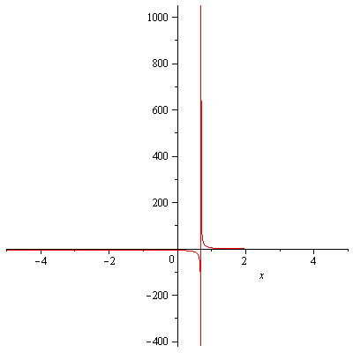

Fig. 2: Singular Kink soliton of JM equation for within the interval. (Only shows the shape of), the left figure shows the 3D plot and the right figure shows the 2D plot for.

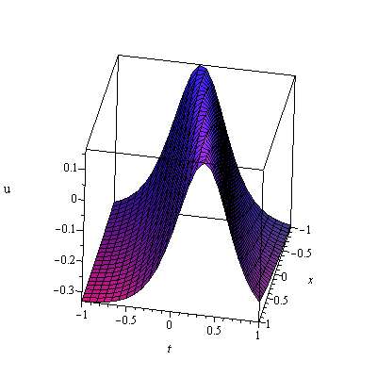 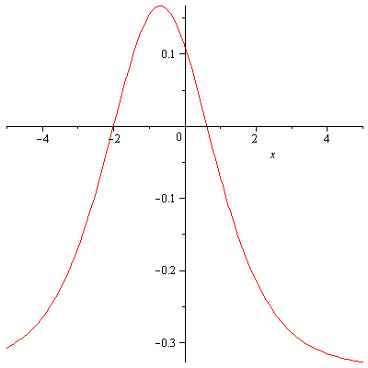

Fig. 3: Bell-shaped soliton of KP equation for within the interval. (Only shows the shape of), the left figure shows the 3D plot and the right figure shows the 2D plot for.

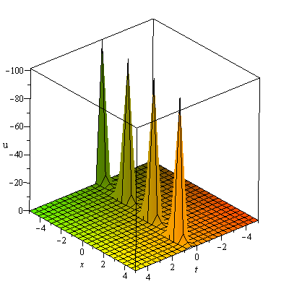 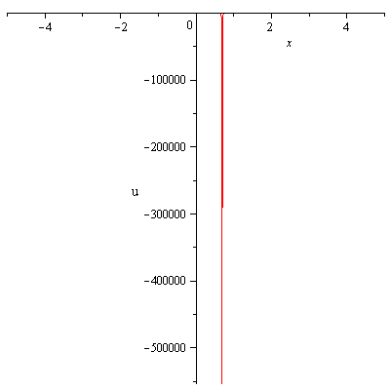

Fig. 4: Singular soliton of KP equation for within the interval. (Only shows the shape of), the left figure shows the 3D plot and the right figure shows the 2D plot for.

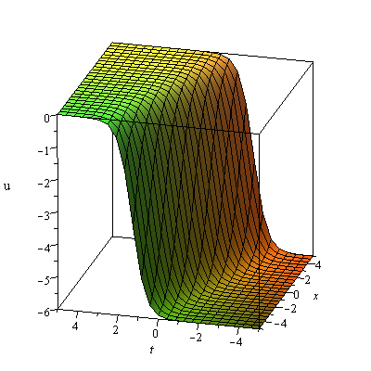 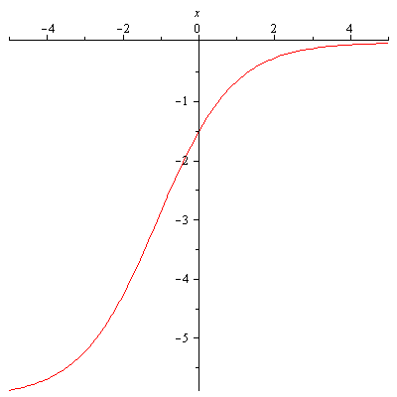

Fig. 5: Kink shaped soliton of ZK equation for within the interval. (Only shows the shape of), the left figure shows the 3D plot and the right figure shows the 2D plot for.

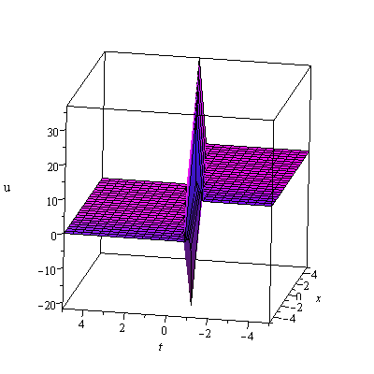 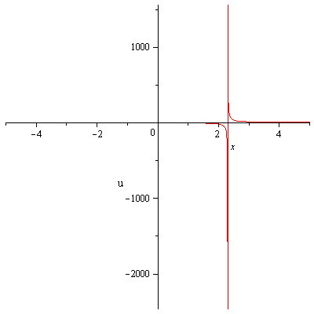

Fig. 6: Singular Kink soliton of ZK equation for within the interval. (Only shows the shape of), the left figure shows the 3D plot and the right figure shows the 2D plot for.

**5. Conclusions**

The generalized Kudryashov method is effectively applied to establish exact traveling wave solutions to the (3+1)-dimensional Jimbo-Miwa (JM) equation, the (3+1)-dimensional Kadomtsev-Petviashvili equation and the (3+1)-dimensional Zakharov-Kuznetsov (ZK) equation. The aim of this work is to present a reliable treatment for studying of these three equations. The generalized Kudryashov method is very effective to construct exact solutions and gives more general solutions. The attained solutions may be convenient for understanding the mechanism of the intricate nonlinear physical phenomena in wave collaboration. These consequences are going to very convenient for leading research in future.

**References**

[1] Wang M L, Zhou Y B, Li Z B, 1996. Application of a homogeneous balance method to exact solutions of nonlinear equations in mathematical physics. *Physics Letters A*, 216, 67-75.

[2] Wang M L, 1996. Exact solutions for a compound KdV-Burgers equation. *Physics Letters A*, 213, 279–287.

[3] Zhang S, Xia T C, 2007. A generalized new auxiliary equation method and its applications to nonlinear partial differential equations. *Physics LettersA*. 363, 356– 360.

[4] Sirendaoreji, Jiong S, 2003. Auxiliary equation method for solving nonlinear partial differential equations. *Physics LettersA*, 309, 387–396.

[5] Wu X H, He J H, 2008. EXP-function method and its application to nonlinear equations. *Chaos, Solitons & Fractals*, 38, 903–910.

[6] Wu X H, He J H, 2007. Solitary solutions, periodic solutions and compacton- like solutions using the Exp-function method. *Computers & Mathematics with Applications*. 54, 966–986.

[7] Hu H C, Tang X Y, Lou S Y, Liu Q P, 2004. Variable separation solutions obtained from Darboux transformations for the asymmetric Nizhnik-Novikov-Veselov system.*Chaos,* *Solitons & Fractals*. 22, 327–334.

[8] Leble S B, Ustinov N V, 1993. Darboux transforms, deep reductions and solitons. *Journal of Physics A*, 26, 5007–5016.

[9] Abdusalam H A, 2005. On an improved complex tanh-function method. *International Journal of Nonlinear Sciences and* *Numerical Simulation*. 6, 99–106

[10] Lee J, Sakthivel R, 2011. New exact travelling wave solutions of bidirectional wave equations. *Pramana Journal of Physics*. 76, 819–829.

[11] Parkes E J, Duffy B R, Abbott P C, 2002. The Jacobi elliptic-function method for finding periodic-wave solutions to nonlinear evolution equations. *Physics Letters A*. 295, 280–286.

[12] Liu S K, Fu Z T, Liu S D, Zhao Q, 2001. Jacobi elliptic function expansion method and periodic wave solutions of nonlinear wave equations. *Physics Letters A*. 289, no. 1-2, 69–74.

[13] Bekir A, Ünsal Ö, 2012. Analytic treatment of nonlinear evolution equations using first integral method. *Pramana- j. phys.* 79(1), 3–17.

[14] Abbasbandy S, Shirzadi A, 2010. The first integral method for modified Benjamin– Bona–Mahony equation. *Commun. Nonlinear Sci Numer Simulat* 15**,**1759–1764.

[15] Jawad A J M, Petkovic MD, Biswas A, 2010 Modified simple equation method for nonlinear evolution equations. *Appl. Math. Comput.* 217,869–877.

[16] Khan K, Akbar M A, 2013. Exact and Solitary Wave Solutions for the Tzitzeica-Dodd-Bullough and the Modified KdV-Zakharov-Kuznetsov Equations using the Modified Simple Equation Method. *Ain Shams Engineering Journal* 4, 903–909. (doi.org/10.1016/j.asej.2013.01.010)

[17] Khan K, Akbar M A, 2014. Exact Solutions of the (2+1)-dimensional cubic Klein- Gordon Equation and the (3+1)-dimensional Zakharov-Kuznetsov Equation Using the Modified Simple Equation Method. *J. Assoc. Arab Uni. Basic Appl. Sci.* 15, 74– 81.(doi.org/10.1016/j.jaubas.2013.05.001)

[18] Wang M, Li X, Zhang J, 2008. The ****-expansion method and travelling wave solutions of nonlinear evolution equations in mathematical physics. *Phys. Lett. A.* 372, 417-423.

[19] [Kim](http://www.sciencedirect.com/science/article/pii/S0034487713600129) H, [Sakthivel](http://www.sciencedirect.com/science/article/pii/S0034487713600129) R, 2012. New exact travelling wave solutions of some nonlinear higher dimensional physical models. *Reports Math. Phys.* 70, 39-50.

[20] Khan K, Akbar M A, 2013.Traveling Wave Solutions of Nonlinear Evolution Equations via the Enhanced (*G'/G*)-expansion Method. J Egyptian Math Soc 2014; 22(2): 220–226. (http://dx.doi.org/10.1016/j.joems.2013.07.009)

[21] Islam M E, Khan K, Akbar M A, Islam R, 2013. Traveling wave solutions of nonlinear evolution equations via enhanced (*G'/G*)-expansion method. GANIT*J. Bangladesh Math. Soc.* 33, 83 - 92.

[22] Naher H, Abdullah F A, 2014. New generalized and improved (G′/G)-expansion method for nonlinear evolution equations in mathematical physics. *Journal of the Egyptian Mathematical Society*, *22*(3), 390-395.

[23] Naher H, Abdullah F A, Bekir A, 2012. Abundant traveling wave solutions of the compound KdV-Burgers equation via the improved (G′/G)-expansion method. *AIP Advances*, *2*(4), 042163. (http://dx.doi.org/10.1063/1.4769751).

[24] Naher H, Abdullah F A, 2014. Some new traveling solutions of the nonlinear reaction diffusion equation by using the improved (G′/G)-expansion method. *Mathematical Problems in Engineering*, *2012*, 17. (http://dx.doi.org/10.1155/2012/871724).

[25]Naher H, Abdullah F A, Akbar M A, 2013. Generalized and improved (G′/G)- expansion method for (3+ 1)-dimensional modified KdV-Zakharov-Kuznetsev equation. *PloS one*, *8*(5), e64618.

[26] Mohiud-Din S T, 2007. Homotopy perturbation method for solving fourth-order boundary value problems. Math. Prob. Engr. 2007, 1-15. (doi:10.1155/2007/98602.)

[27] Mohyud-Din S T, Noor M A, 2009. Homotopy perturbation method for solving partial differential equations. *Zeitschrift für Naturforschung A- A J. Phys.Sci.* 64a 157-170.

[28] Mohyud-Din S T, Yildrim A, Sariaydin S, 2010. Approximate Series Solutions of the Viscous Cahn-Hilliard Equation via the Homotopy Perturbation Method. *World Appl. Sci.* J. 11(7), 813-818.

[29] Changbum C, Rathinasamy S, 2010. Homotopy perturbation technique for solving two-point boundary value problems–comparison with other methods. *Computer Physics Communications*, 181(6), 1021–1024. (DOI: 10.1016/j.cpc.2010.02.007)

[30] Rathinasamy S, Changbum C, Jonu L, 2010. New Travelling Wave Solutions of

Burgers Equation with Finite Transport Memory. *Zeitschrift fur Naturforschung- A*  65, 633-640.

[31] Khan K, Akbar M A, 2013. Application of exp-expansion method to find the exact solutions of modified Benjamin*-*Bona*-*Mahony equation. *World Appl. Sci. J*. 24 (10), 1373-1377. (DOI: 10.5829/idosi.wasj.2013.24.10.1130)

[32] Molliq R Y, Noorani M S M, Hashim I, 2009. Variational iteration method for fractional heat-and wave-like equations. *Nonlinear Analysis: Real World Appl.* 10 (3), 1854-1869. (**DOI:** 10.1016/j.nonrwa.2008.02.026.)

[33] Zhao Y M, 2013. *F*-Expansion Method and Its Application for Finding New Exact Solutions to the Kudryashov-Sinelshchikov Equation. *J. Appl. Math*. 2013, 8.(doi.org/10.1155/2013/895760)

[34] Hua H W, 2006. A Generalized Extended *F*-Expansion Method and Its Application in (2+1)-Dimensional Dispersive Long Wave Equation. *Commun. Theor. Phys.* 46(4) 580 (doi:10.1088/0253-6102/46/4/002)

[35] Islam M S, Khan k, Akbar MA, Mastroberardino A, 2014. A note on improved expansion method combined with Riccati equation applied to nonlinear evolution equations*. R. Soc. Open Sci.* **1**: 140038. http://dx.doi. org/10.1098/rsos.140038

[36] Jimbo M, Miwa T, 1983. Solitons and infinite dimensional Lie algebras. *Publ. Res. Inst. Math. Sci.* 19, 943-1001

[37] Senthilvelan M, 2001. On the extended applications of homogenous balance method. *Appl. Math. Comput*. 123, 381-388.

[38] Tang XY, Liang ZF, 2006. Variable separation solutions for the (3 + 1)-dimensional Jimbo-Miwa equation*. Phys. Lett. A* 351,398-402

[39] Wazwaz AM, 2008. New solutions of distinct physical structures to high-dimensional nonlinear evolution equations. *Appl.Math. Comput*. 196, 363-370.

[40] Li Z, Dai Z, Liu J, 2011. Exact three-wave solutions for the (3+1)-dimensional Jimbo-Miwa equation*. Comput. Math. Appl*. 61, 2062-2066

[41] Wazwaz AM, 2009. Partia l Differential Equations and Solitary Waves Theory, Higher Education Press, *Beijing and Springer-Verlag Berlin*, Heidelberg.

[42]  Demiray S T, Pandir Y, Bulut H, 2014. The investigation of exact solutions of nonlinear time-fractional Klein-Gordon equation by using generalized Kudryashovmethod. *AIP Conference Proceedings* 1637: 283 (doi: 10.1063/1.4904590)

[43] Akbar M A, Ali N H M, Mohyud-Din S T, 2012. Some New Exact Traveling Wave Solutions to the (3+1)-dimensional Kadomtsev-Petviashvili equation, *World Appl. Sci. J.*, 16 (11): 1551-1558

# [44] Alagesan T, Uthayakumar A, Porsezian K, 1997. Painlevé analysis and Bäcklund transformation for a three-dimensional Kadomtsev-Petviashvili equation*. Chaos, Solitons and Fractals* 8, 893