# Solution of the Two- Dimensional Heat Equation for a Rectangular Plate

Emel KURULa

Nurcan BAYKUŞ SAVAŞANERİLb

a Department of Mathematics, Faculty of Sciences, Selçuk University, Konya, Turkey

b Izmir Vocational School, Dokuz Eylül University, Izmir, Turkey

a [emelkurul@gmail.c](mailto:emelkurul@gmail.c)om b [nurcan.savasaneril@deu.edu.tr](mailto:nurcan.savasaneril@deu.edu.tr)

**Abstract**

Laplace equation is a fundamental equation of applied mathematics. Important phenomena in engineering and physics, such as steady-state temperature distribution, electrostatic potential and fluid flow, are modeled by means of this equation. The Laplace equation which satisfies boundary values is known as the Dirichlet problem. The solutions to the Dirichlet problem form one of the most celebrated topics in the area of applied mathematics. In this study, a novel method is presented for the solution of two-dimensional heat equation for a rectangular plate. In this alternative method, the solution function of the problem is based on the Green function, and therefore on elliptic functions.

Keywords: Heat equation; Dirichlet problem; Elliptic functions; Elliptic integral; Green function.

# INTRODUCTION

Laplace’s equation is one of the most significant equations in physics. It is the solution to problems in a wide variety of fields including thermodynamics and electrodynamics. Today, the theory of complex variables is used to solve problems of heat flow, fluid mechanics, aerodynamics, electromagnetic theory and practically every other field of science and engineering. A broad class of steady-state physical problems can be reduced to finding the harmonic functions that satisfy certain boundary conditions. The Dirichlet problem for the Laplace equation is one of the above mentioned problems.

The Dirichlet problem is to find a function that is harmonic in a bounded domain , is continuous up to the boundary of , assumes the specified values  on the boundary , where  is a continuous function on , and can be formulated as

 (1)

Here, for a point  in the plane , one takes the complex notation ,  and  are real functions and  is the Laplace operator. Similarly the Dirichlet problem for the Poisson equation can be formulated as

 (2)

Brovar et al. [1] investigated the relation between the Dirichlet problem and the Cauchy problem. Sezer [2] developed a new method for the solution of Dirichlet problem. Lanzara [3] studied Dirichlet problem for second degree elliptic linear equations with limited and measurable coefficients. The dependence upon variations of problem data of the solution of two-dimensional Dirichlet boundary value problem for simply connected regions was investigated [4]. Han and Hasebe [5] derived Green's function for a thermomechanical mixed boundary value problem of an infinite plane with an elliptic hole under a pair of heat source and sink. In another study, Han and Hasebe [6] also reviewed Green's functions for a point heat source in various thermoelastic boundary value problems for an infinite plane with an inhomogeneity. Green function of the Dirichlet problem for the Laplace differential equation in a rectangular domain was expressed in terms of elliptic functions and the solution of the problem was based on the Green function and therefore on elliptic functions by Kurt et al. [7]. Hsiao and Saranen [8] showed an equivalence between the weak solution and the various boundary integral solutions, and described a coupling procedure for an exterior initial boundary value problem for the nonhomogeneous heat equation. The problem of the one-dimensional heat equation with nonlinear boundary conditions was studied by Tao [9]. Hansen [10] studied a boundary integral method for the solution of the heat equation in an unbounded domain D in R². The application of spectral methods for solving the one-dimensional heat equation was presented by Saldana et al. [11]. Al-Najem et al. [12] estimated the surface temperature in two-dimensional steady-state in a rectangular region by two different methods, the singular value decomposition with boundary element method and the least-squares approach with integral transform method. The Green function of the Dirichlet problem for the Laplace differential equation in a triangle region was expressed in terms of elliptic functions and the solution of problem was based on the Green function, and therefore on elliptic functions by Kurt and Sezer [13]. Green function of the two-dimensional heat equation in a square region was expressed in terms of elliptic functions and the solution of the problem was based on the Green function and therefore on elliptic functions by Kurt [14]. Least Square Method (LSM), Collocation Method (CM) and a new approach which is called Akbari-Ganji’s Method (AGM) are applied to solve the nonlinear heat transfer equation of fin with power-law temperature-dependent both thermal conductivity and heat transfer coefficient by Ledari et al. [15].

As it is known, the solution of the Dirichlet problem by the method of separation of variables may be obtained only for a restricted class of domains  with a sufficiently simple boundary . The conformal mappings yield a sufficiently universal algorithm for the solution of the Dirichlet problem for two-dimensional domains. These permit constructing a Green function of the Dirichlet problem for the Laplace (and Poisson) equation in a conformally mapped onto the unit circle or upper half-plane, and cannot be obtained in terms of elliptic functions.

Our purpose in this paper is, first, to determine the analytic function which maps the rectangular domain  onto the upper half-plane or the unit circle in terms of elliptic functions using the Schwarz-Christoffel transformation and conformal mapping, and then, to find the solution of the Dirichlet problem for the rectangular domain in terms of elliptic functions, by means of the relation between the obtained analytic function and the Green function.

# ELLIPTIC INTEGRALS AND FUNCTIONS

The integral

 (3)

is called the normal elliptic integral of the first kind, where **is any number. When , Eq. (3) is said to be complete and becomes

 (4)

or

 (5)

Here, the number *k* is the modulus and  is the complementary modulus, such that. If  in Eq. (3), one finds that  or . When, the integral (3) is denoted by  or briefly  or . The function  is called Jacobian elliptic function. Two other Jacobian elliptic functions can be defined by ., .

# THE CONFORM MAPPING OF A RECTANGULAR DOMAIN

Let apply the transformation  to carry the rectangle onto the first quadrant. The function, with , maps the rectangle onto the first quadrant of the plane. The function  maps this quadrant onto the upper half of the plane. The following table shows where the corresponding points lie in different planes (including the final w-plane):

|  |  |  |  |  |
| --- | --- | --- | --- | --- |
| *plane* | A | B | C | D |
|  |  |  |  |  |
|  |  |  |  |  |
|  |  |  |  |  |
|  |  |  |  |  |
|  |  |  |  |  |
|  |  |  |  |  |

The last two rows define the bilinear transformation between the  and the planes:

 (6)

That is,

 (7)

On the other hand,

 (8)

Hence,



 (9)

Multiply the numerator and denominator by the denominator with instead of (not the conjugate!). Using  and  and simplifying, we obtain:

# (10)

The conformal mapping of the rectangle given in the *z*-plane onto the unit circle  in the plane can be written as

  (11)

which is illustrated in Fig. 1. [16]

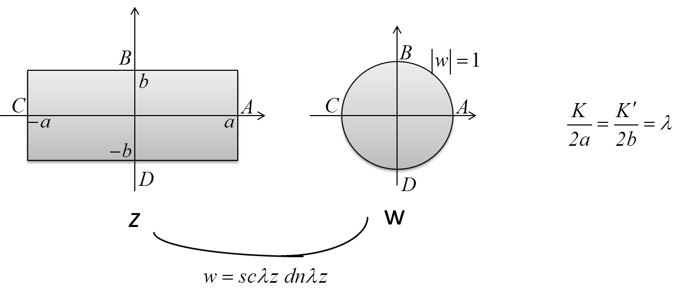

Fig. 1. Conformal mapping of the rectangular area in the z-plane onto the unit circle in the w-plane.

# DETERMINATION OF GREEN FUNCTION

Green function  of the Dirichlet problem for the Laplace equation in the domain  is defined by

 (12)

where *g* is a harmonic function in  for each  and  then , for each  and .

When the domain is simply connected, the determination of the mentioned Green function can be reduced to the problem of determining an analytic function which specifies a mapping of  onto the upper half-plane  or the unit circle . This is because  is an analytic function which maps the domain  in the -plane onto the upper half-plane of the plane, with  in  then the mapping is one-to-one.

 (13)

and, if the analytic function  maps  onto the unit circle , then the Green function of the Dirichlet problem for the Laplace operator in  becomes

 (14)

Consequently, if one takes  as the rectangle,, ,  then from Eqs. (12) and (14), the Green function for the rectangle is found in the form

 (15)

# THE SOLUTION OF THE DIRICHLET PROBLEM

The solution of the Dirichlet problem for the Poisson equation (2) in  can be obtained as

 (16)

where  is the Green function for the domain  and  denotes differentiation along an outward normal to the boundary  of  with respect to .

Taking the domain  as the rectangle ,, ,  and the boundary  of  as the circumference , one may write the conditions

1.  on 
2.  on 
3.  on 
4.  on 

Thus, from Eq. (16), the solution of Eq. (2) in the above rectangle becomes



 (17)

In the case of , the solution of the Dirichlet problem for the Laplace differential equation (1) in the above rectangle is obtained in terms of elliptic functions as :

 (18)

where the Green function  is defined by

, 

according to Eq. (14). The boundary values  and  are the complete elliptic integrals and are tabulated for the range .

# ILLUSTRATIVE APPLICATION

In this section, an illustrative example is given. The boundary of a rectangular sheet of metal is kept at constant temperature 500C on the upper edge, 200C on the bottom edge, and 00C on the other two edges. After a sufficient period of time, the temperature inside the plate reaches an equilibrium distribution. This steady-state temperature distribution  is determined in this application. Since no heat sources are present in the plate, the steady-state temperature must satisfy

 (19)

The boundary conditions are

 (20)

The solution of  with two real variables satisfying the above conditions by the method of separation variables is

 (21)

where  On the other hand, the solution of the

 (22)



where

  (23)

Substituting the conditions (23) into Eq. (22) yields



where



# DISCUSSION.

The most significant advantage of present method is that the result is obtained in terms of elliptic functions; because expressing the result in terms of elliptic functions facilitates many physics and engineering problems. An alternative method is presented for the solution of two-dimensional heat equation for a rectangular plate. Following the way in the present paper, the heat equation in similar plates, namely the ellipse, square and polygon plates, can be solved in terms of elliptic functions; thus, a major contribution can be made to the solution of similar problems in physics and engineering.

**References**

[1] V.V. Brovar, Z.S. Kopeikina, M.V. Pavlova, Solution of the Dirichlet and Stokes exterior boundary problems for the Earth’s ellipsoid, J. Geodesy 74 (2001) 767-772.

[2] M. Sezer, Solution of Dirichlet Problem in Terms of Elliptic Functions, Yıldız Üniversitesi Dergisi, 4 (1992) 1-4.

[3] F. Lanzara, Numerical approximation of eigenvalues and of Green’s operator for an elliptic boundary value problem, Calcolo 35 (1998) 63-92.

[4] A. Marshakov, P. Wiegmann, A. Zabrodin, Integrable structure of the Dirichlet boundary problem in two dimensions, Commun. Math. Phys. 227 (2002) 131-153.

[5] J.J. Han, N. Hasebe, Green’s function for a thermomechanical mixed boundary value problem of an infinite plane with an elliptic hole, J. Thermal Stresses 24 (2001) 903-916.

[6] J.J. Han, N. Hasebe, Green’s functions of point heat source in various thermoelastic boundary value problems, J. Thermal Stresses 25 (2002) 153-167.

[7] N. Kurt, M. Sezer, A. Çelik, Solution of Dirichlet problem for a rectangular region in terms of elliptic functions, J. Comput. Math. 81 (2004) 1417-1426.

[8] G.C. Hsiao, J. Saranen, Boundary integral solution of the two-dimensional heat equation, Math. Methods Appl. Sci. 16 (2) (1993) 87-114.

[9] L.N. Tao, The analyticity of solution of the heat equation with nonlinear boundary conditions, Quart. Mech. Appl. Math. 38 (1985) 447-459.

[10] O. Hansen, On a boundary integral method for the solution of the heat equation in unbounded domains with nonsmooth boundary, J. Integral Equation Appl. 12 (2000) 385-420.

[11] J.G. Saldana, J.A.J. Bernal, C.G. Torres, P.Q. Diez, Numerical solution for the one-dimension heat equation by a pseudo-spectral discretization technique, Cientifica 10(1) (2006) 3-8.

[12] N.M. Al-Najem, A.M. Osman, M.M. El-Refaee, K.M. Khanafer, Two- dimensional steady-state inverse heat conduction problems, Int. Commun. Heat Mass Transfer 25 (1998) 541-550.

[13] N. Kurt, M. Sezer, Solution of Dirichlet problem for a triangle region in terms of elliptic functions, Appl.Math. Comput. 182 (2006) 73-78.

[14] N.Kurt, Solution of the two-dimensional heat equation for a square in terms of elliptic functions, Journal of the Franklin Institute, 345(3) 2007 303-317.

[15]S.T. Ledari, H. Mirgolbabaee and D. D. Ganji,Heat transfer analysis of a fin with temperature-dependent thermal conductivity and heat transfer coefficient, New Trends in Mathematical Sciences, 2015.

[16] G. Moretti, Functions of Complex Variable, Prentice-Hall, NJ, 1964.

[17] F.B. Hildebrand, Advanced Calculus for Applications, Prentice-Hall Inc. Englewood Cliffs, NJ, 1976.

[18] P.R. Garabedian, Partial Differential Equations, John Wiley and Sons Inc., New York, 1964.